Ian Parkison

CSE598

Testing Document

Assignment 4

This service tests if an xml document is valid against its schema document. The following screen shot is of a valid comparison of xml and xsd files.

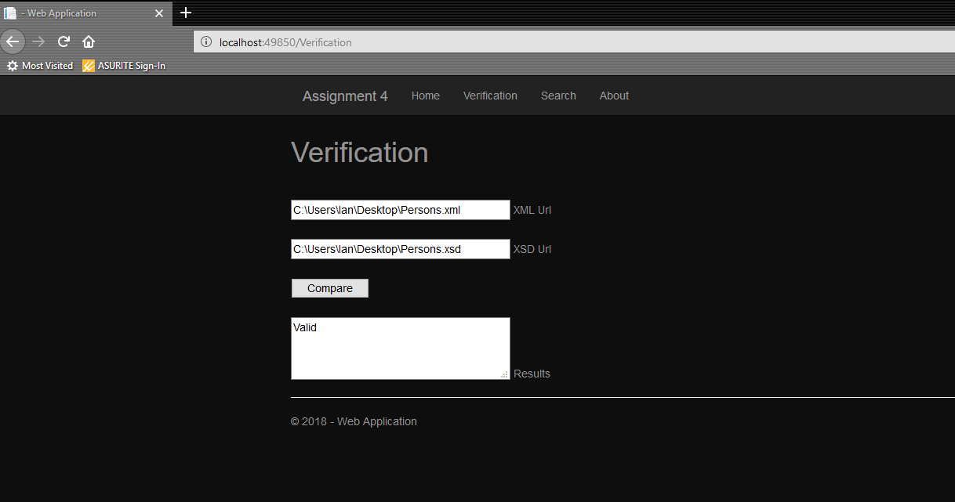

The follow is an error screen shot where I put a non-numeric character into the phone number element. This cause the error message below to print.

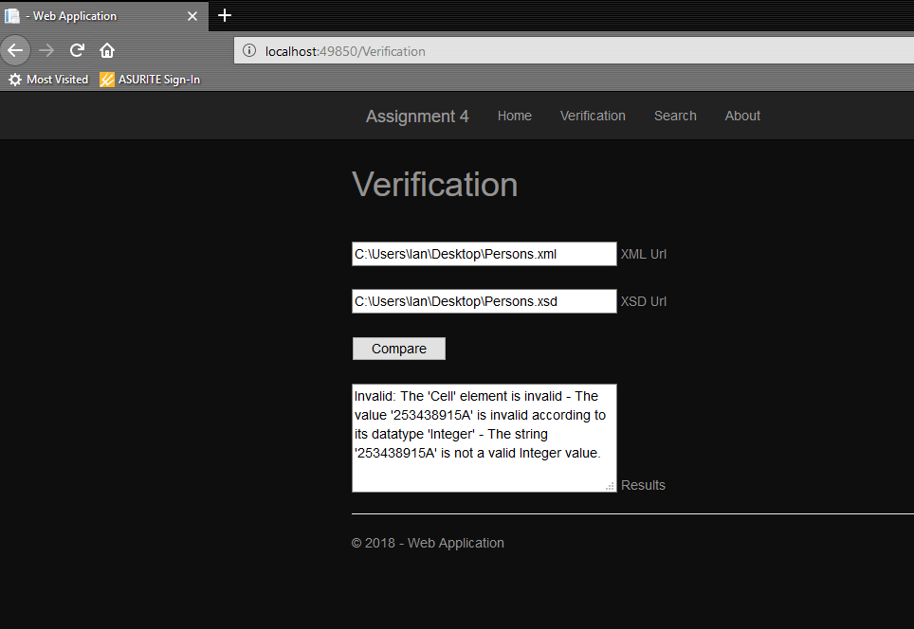

The next service is the search service. The below screen shot is an image of the search criteria and the output from searching “Jason”. Jason has the optional cell phone provider attribute.

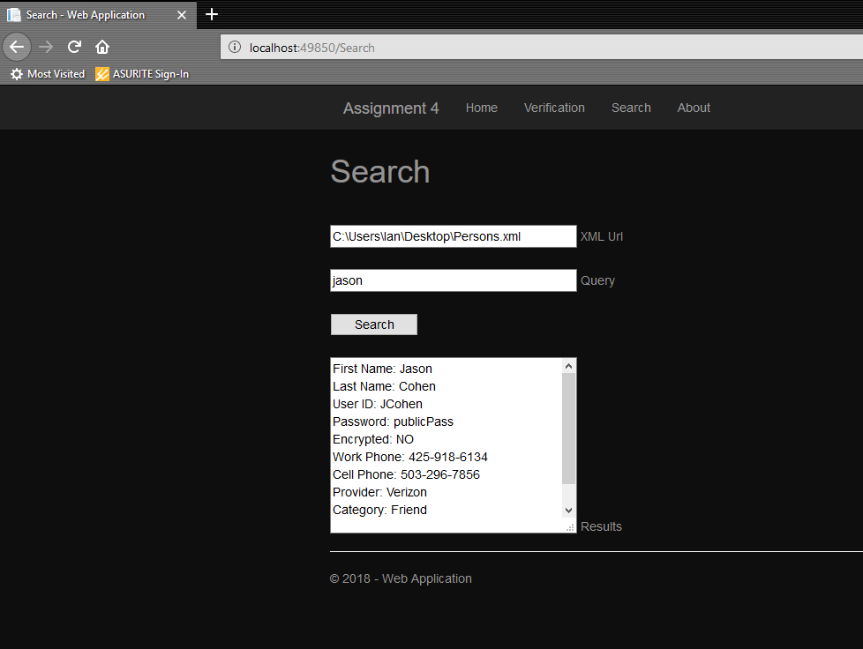

The nest screen shot is a search for “steve”. Steve doesn’t have the optional cell phone provider attribute and so it doesn’t show up.

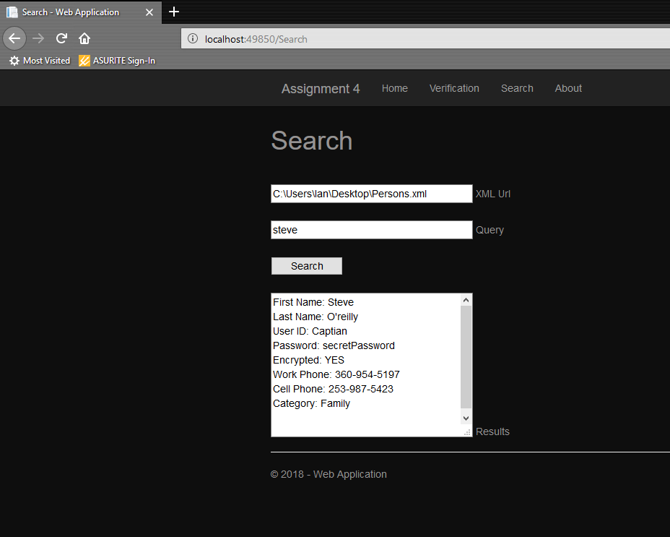

Lastly, I searched for results that I knew were not present in the xml file. I received the “No Results…” message as expected.

